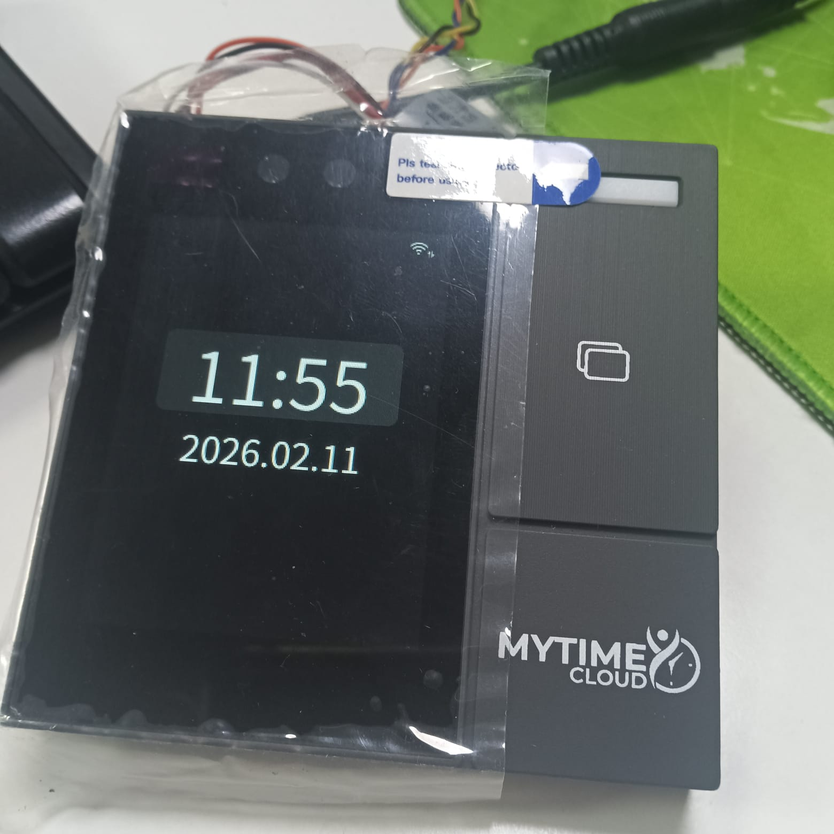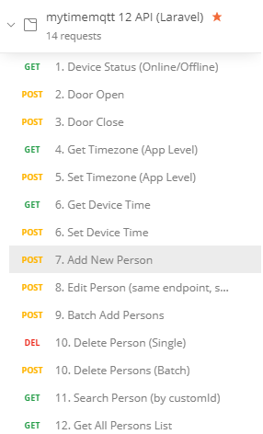

Admin
Password : 123456
- Device status – Online - working
- Door Open – working
- Door Close – Working
- Always Open – Time zone Function is not available
- Time Sync – Working
- Employee Upload To Device – Working
- Employee List – Find Device – working
- Employee Delete From Device - Working
- Device – Search Employee Id – working
- Device Settings – Reading only People Count – working
- Employee Logs – Working

